|  |  |
| --- | --- |
|  |  |
| Smart Home |  |
|  |  |
|  | 15.7.2021Embedded System Diploma |
|  | Ali Amr GoudaT11 |

|  |  |  |  |
| --- | --- | --- | --- |
|  |  |  |  |
|  | Introduction:Smart Home project consists of two micro-controllers ATmega32a and virtual terminal (used in proteus) to send the commands to the first controller using UART communication protocol and then the first controller takes the data and send it to the second controller (actuator) using SPI communication protocol and then the actuator translate the command to action which is to turn on or turn off any of two LEDs.Commands Used:  1. Signal ‘0’ turns LED 1 off 2. Signal ‘1’ turns LED 1 on 3. Signal ‘2’ turns LED 2 on 4. Signal ‘3’ turns LED2 off | |  |
|  | Software Architecture: |  |  |

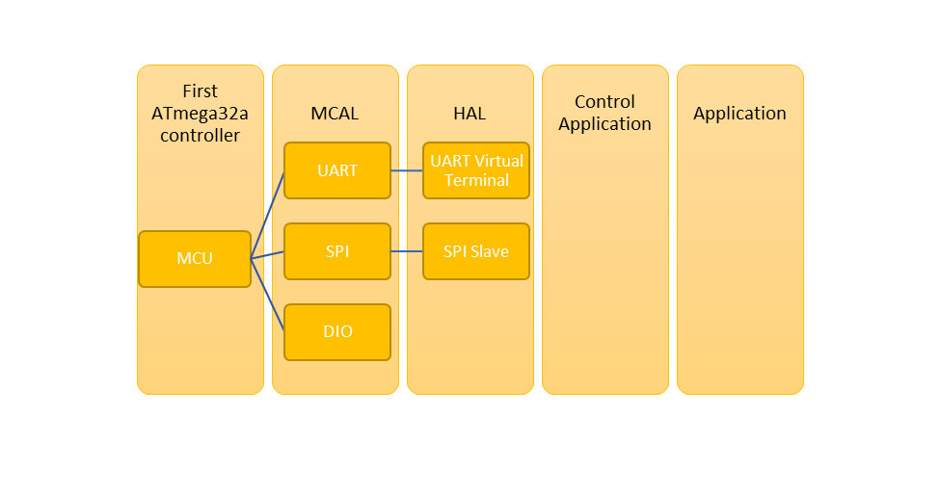

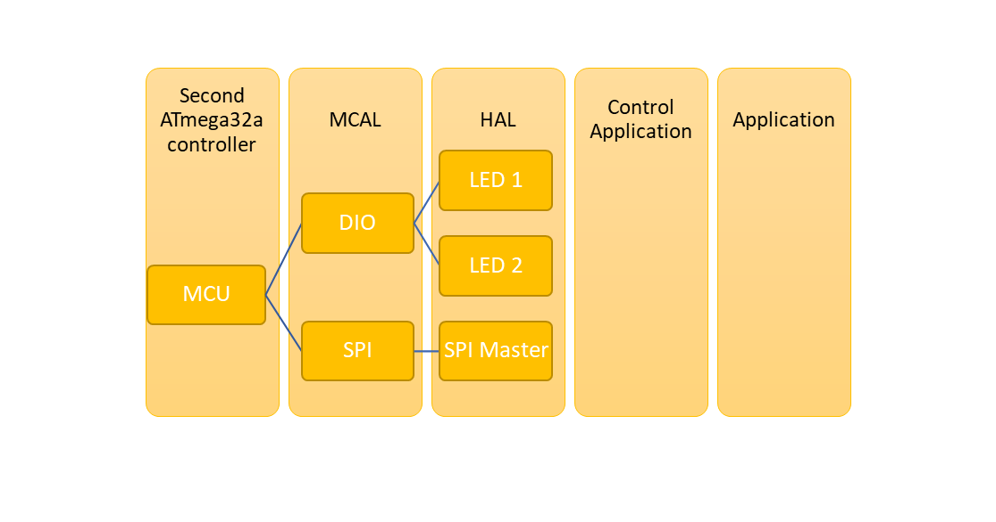

|  |  |  |  |
| --- | --- | --- | --- |
|  |  |  |  |
|  | System Flow Chart: | |  |

